gehc_extended_black

Information Technology and Process Excellence

Smart Dispatch Tool (SDT) Booking Web App

Technical Architecture Description for Smart Dispatch Tool – SDT Booking Web App

High level technical architecture as implemented for Smart Dispatch Tool – SDT Booking Web App

Revision of this document is controlled by the MyWorkshop system. Copies can be obtained via MyWorkshop. The master document (source file) is generated and maintained by Information Technology and Process Excellence Services.

**Document ID:** DOC1757330

**Author(s):** Chandramohan Gupta, ITPM, GEHC ITPE.

**Reviewer(s):** Sirasala Subba, Web Platform Architect, GEHC ITPE

**Approver(s):** Sirasala Subba, Web Platform Architect, GEHC ITPE

Mahesh Iyer, Validation Manager, GEHC ITPE

**Note:** Before using this document, make sure it is the latest revision. Access the My Workshopsystem to verify the current revision.

Any printout of this document is considered an uncontrolled copy.

This document is proprietary to GE Healthcare.

**Document Revision History**

|  |  |  |  |  |
| --- | --- | --- | --- | --- |
| Revision | **Date** | **Author** | **Change Reference** | **Reason for Change** |
| 1 | See MyWorkShop | Chandramohan Gupta | All pages | Initial release |

**Contents**

[1 PURPOSE 4](#_Toc452041474)

[2 INTRODUCTION 4](#_Toc452041475)

[3 SCOPE 5](#_Toc452041476)

[3.1 In Scope 5](#_Toc452041477)

[3.2 Out of Scope 5](#_Toc452041478)

[4 DEFINITIONS/ACRONYMS 6](#_Toc452041479)

[5 REFERENCES 7](#_Toc452041480)

[6 TECHNICAL LANDSCAPE 7](#_Toc452041481)

[6.1 Prospective Landscape 7](#_Toc452041482)

[6.1.1 Logical System Diagram 8](#_Toc452041483)

[6.1.2 Physical System Diagram 9](#_Toc452041484)

[6.1.3 Backup/Recovery of systems 11](#_Toc452041485)

[6.1.4 System Technical and Server Provisioning Details 11](#_Toc452041486)

[6.1.5 Qualification Process 14](#_Toc452041487)

[7 FURTHER SYSTEM DETAILS 15](#_Toc452041488)

[7.1 Networks 15](#_Toc452041489)

[7.2 Interfaces 15](#_Toc452041490)

[7.3 Printers and Other Devices 15](#_Toc452041491)

# PURPOSE

The purpose of this document is to describe the high-level technical architecture of the GE Healthcare (GEHC) SDT Booking Web App implementation at Tower, US Data Centre. It defines the SDT Booking Web App architecture and technical components.

This Technical Architecture Description will be updated as required due to system upgrades, additions and/or modifications to the infrastructure components (either hardware or software) and will be managed through the GEHC\_GQP\_12.10.001 Change Control for Computerized System Validation of Non-Product Software Work Instruction (DOC0407270).

# INTRODUCTION

This Technical Architecture Description (TAD) describes the hardware and infrastructure specifications for the SDT Booking Web App environment and application. The hardware and infrastructure specifications identified herein, arose directly from business requirements and technical necessity for the Smart Dispatch Tool (SDT) Booking to be invoked from the Siebel CRM and obtain the suitable Field Service Engineer(s) (FSE) along with the appointment date and times from ClickSchedule in the APAC region.

The SDT Booking Web App Server is a Windows 2012 64-bit server hosting the custom-built SDT Booking Web App application. Where desirable, features or preferred technical solutions are included. They are resolved in this document to represent the agreed system being delivered.

The TAD is a deliverable as specified in the SDT Booking Validation and Test Plan (VTP) [[5](#VTP)].

# SCOPE

This Technical Architecture Description (TAD) applies only to the installation of infrastructure for the SDT Booking Web App. The infrastructure component(s) for the SDT Booking Web App infrastructure will be prospective and shall follow technology applicable Work Instructions and/or Standards. This TAD document is controlled under the Infrastructure Qualification Standard (DOC1205827).

## In Scope

The scope of this TAD includes the following IT infrastructure for the SDT Booking Web App and all changes to system will be made under change control following the procedures detailed in GEHC\_GQP\_12.10.001 Change Control for Computerized System Validation of Non-Product Software Work Instruction (DOC0407270) - (located in My Workshop).

* Development, Staging, and Production instances of System
* Servers used to host web application

## Out of Scope

The scope of this document also excludes:

* Inbound and outbound interfaces
* Third party applications and tools
* Client configurations
* Printers, plotters, or other physical output devices

All these details, whichever is applicable, are covered as a part of the SDT Booking System Design Specifications document (DOC1502612).

# DEFINITIONS/ACRONYMS

IT QMS Definitions can be found in the Information Technology and Process Excellence Glossary of Terms (DOC0297142). Data Protection definitions may be found in the Data Protection Global Glossary (DOC0549512). The following definitions apply to specialized terms used in this document.

| Term | Definition |
| --- | --- |
| Siebel | CRM System containing the Service Requests and thru which the SDT Booking Web Application is being invoked |
| SDT | Smart Dispatch Tool - an umbrella term that refers to ClickSoftware Technologies (hereafter referred to as ‘ClickSoftware’) configurable commercial off-the-shelf (COTS) suite of products used for the assignment and scheduling of Field Service Engineer (FSE). The suite of products includes:  ClickSchedule - optimizes service scheduling and routing by balancing customer, service and asset resources, and organizational preferences including contractual commitments, priority, drive time, skills, and service and asset resources availability.  ClickMobile - provides wireless workforce management for monitoring field workforce activities and reducing the labor of dispatching personnel. ClickMobile enables job detail notification from the field and allows for field updates. Assignments created in ClickSchedule are dispatched to field devices based on configurable workflows while enabling real-time visibility into workforce activity including job status, start and end time. |
| ClickSchedule | Optimizes service scheduling and routing by balancing customer, service and asset resources, and organizational preferences including contractual commitments, priority, drive time, skills, and service and asset resources availability. |
| ClickMobile | Provides wireless workforce management for monitoring field workforce activities and reducing the labor of dispatching personnel. ClickMobile enables job detail notification from the field and allows for field updates. Assignments created in ClickSchedule are dispatched to field devices based on configurable workflows while enabling real-time visibility into workforce activity including job status, start and end time. |
| SDT Booking Web App | GEHC Custom built web application to dispatch Service request details from Siebel to ClickSchedule and obtaining the appointment slots from SDT Schedule |
| TAD | Technical Architecture Description is an overview of components of the system  (or part thereof) to provide a common representation to teams involved in  Validation/qualification and support. The Technical Architecture Description  includes diagrams, lists and/or descriptions of the logical and/or physical  Relationships of major infrastructure and application components.  May be identified technical architecture plan in older documentation |
| VM | Virtual Machine |
| AWS | Amazon Web Services, which is Amazon vendor providing the services for GEHC. |

# REFERENCES

| Reference | Document ID / Location |
| --- | --- |
| 1. Global Quality Management System Standards | BOK22974 / My Workshop |
| 1. Information Technology & Process Excellence IT Infrastructure Control and Compliance Technology Frameworks | DOC1814847 / My Workshop |
| 1. Information Technology and Process Excellence Glossary of Terms | DOC0297142 / My Workshop |
| 1. PaaS\_Web\_Platforms\_Automation\_Process\_Overview | DOC1814859 |
| 1. Windows Server Infrastructure Framework | BOK47479 / My Workshop |
| 1. SDT Booking Validation and Test Plan | DOC1757332/ My Workshop |
| 1. IT Infrastructure Lifecycle Management Standard | DOC1042816/MyWorkShop |

# TECHNICAL LANDSCAPE

## Prospective Landscape

The underlying infrastructure is provided and supported by GEHC Technology Services – Web CoE and Compute Server organizations.

This Technical Architecture Description describes the GEHC SDT Booking Web App platform as a baseline. All instances should be documented.

The primary content for this document will be the technical architecture diagrams for each instance of the new environment. The goal is to provide an overview of the hardware, the configurations, the network connections as well as interfaces and services between systems. This TAD will cover:

* Logical System Diagram
* Physical System Diagram
* Backup

### Logical System Diagram

#### Logical Environment

#### The development, stage and production environments will consist of a single virtual machine (VM) that meets the global GEHC standard server requirements.

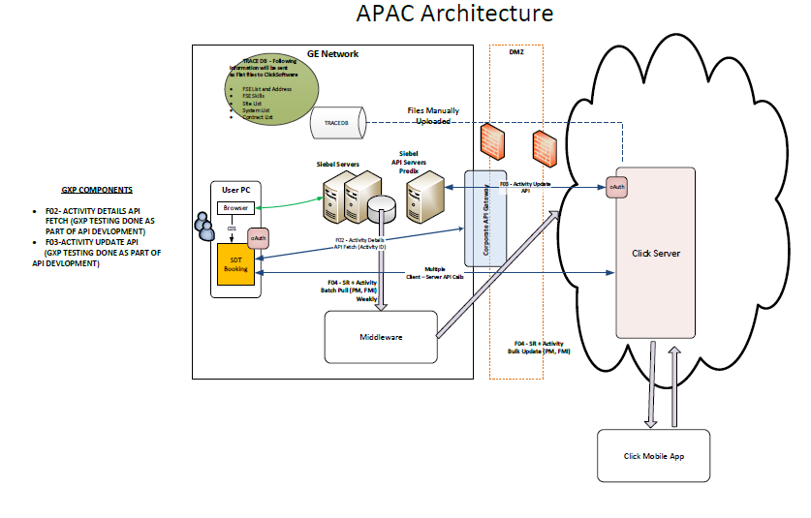

### Physical System Diagram

#### Physical Environment - DEVELOPMENT

The development environment is as follows, where only one IIS web server is configured.

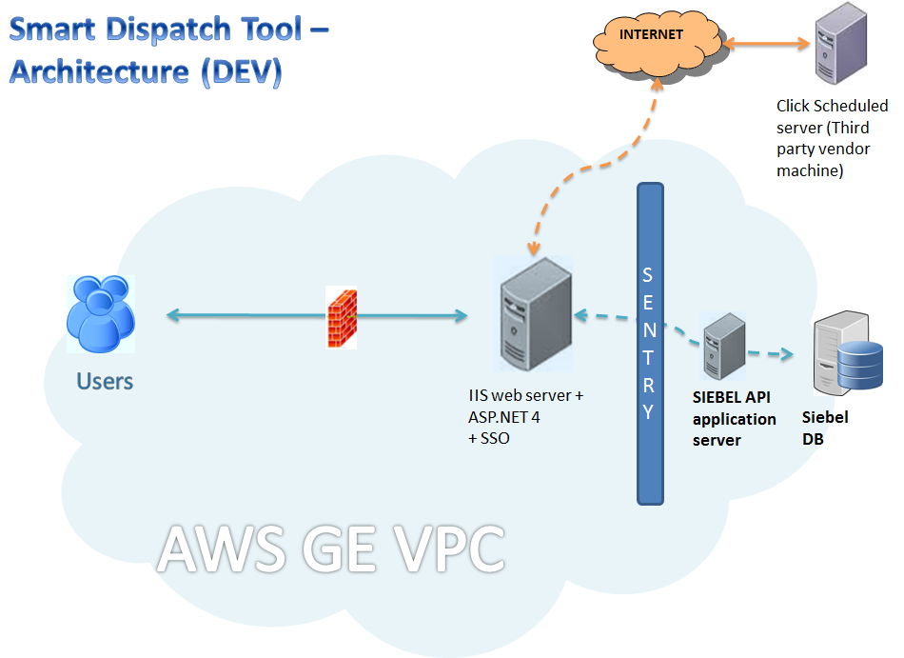

#### Physical Environment – Stage and Production

The stage and production physical environment are as follows:

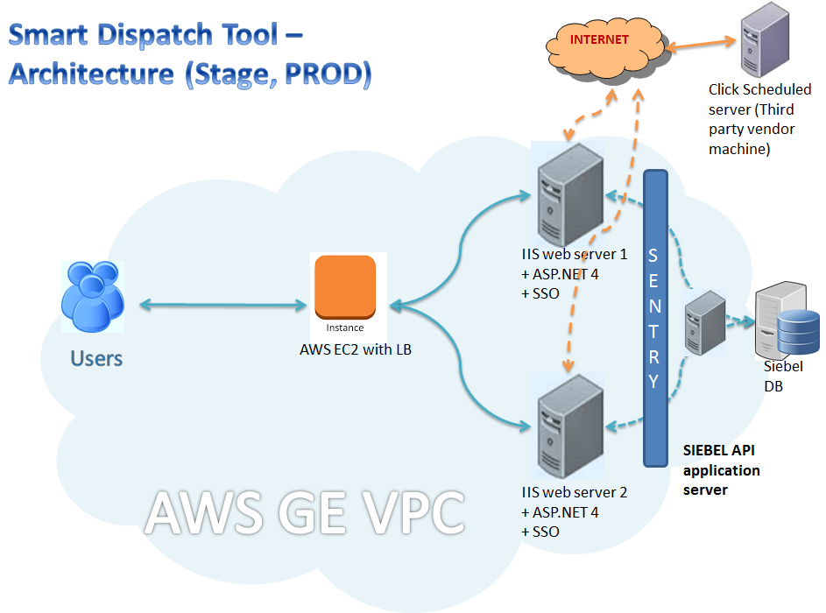

### Backup/Recovery of systems

#### Servers Backup/Recover System Diagram (Data Protection)

The backup mechanism for these systems will follow the existing standards for all allocated space. Backing up the production systems is done as per standards and the stage, development data is not considered as critical and so will not have same backup standards followed.

As per the GEHC AWS Services Backup utility for instance level backup, all volumes attached to an instance will be backed-up via snapshot every 4 hours, provided the instance is tagged with the tag-key of ENV, tag-value of true. This tagging requirement has some heuristic behaviour to allow for common human errors to ensure backups are available. For complete recovery of the system, AWS provides the snapshot services and by using the EC2 instance snapshots, systems are recovered.

.

### System Technical and Server Provisioning Details

GEHC App2cloud teams, on behalf of the SDT application team, will be requesting the staging environment from AWS environment using the SCALR self-provisioning system. The link to access the system is provided below.

<http://scalr.corporate.ge.com/>

The server hostnames are generated automatically while requesting the staging servers through SCALR self-provisioning system. After provisioning the servers, the hostnames are recorded as part of the PaaS technology framework process and TAD to be revised with server hostnames after provisioning all environments.

The SDT application environment consists of the following servers:

#### Development Environment

* 1. **Web Application server:**

|  |  |
| --- | --- |
| Server Name | 53287-6713-1.mgmt.logon.ds.ge.com |
| Instance Type | GEHC AWS EC2 instance – m3.large |
| Server Location | AWS US region |
| Operating System | Windows 2012 R2 Server |
| Software Pre-requisites | IIS 8.0  .NET Framework 4.5 |
| Processor | 2 CPU or more |
| Memory | 8 GB |
| Storage | 50 GB (Free space for application) |

#### Staging Environment

1. **Web Application server 1:**

|  |  |
| --- | --- |
| Instance Type | GEHC AWS EC2 instance - – m3.xlarge/c4.xlarge |
| Server Location | AWS US region |
| Operating System | Windows 2012 R2 Server |
| Software Pre-requisites | IIS 8.0  .NET Framework 4.5 |
| Processor | 4 CPU or more |
| Memory | 8 GB |
| Storage | 100 GB (Free space for application) |

**ii. Web application server 2:**

|  |  |
| --- | --- |
| Instance Type | GEHC AWS EC2 instance- m3.xlarge/c4.xlarge |
| Server Location | AWS US region |
| Operating System | Windows 2012 R2 Server |
| Software Pre-requisites | IIS 8.0  .NET Framework 4.5 |
| Processor | 4 CPU or more |
| Memory | 8 GB |
| Storage | 100GB (Free space for application) |

#### Production Environment

1. **Web Application server 1:**

|  |  |
| --- | --- |
| Instance Type | GEHC AWS RDS instance - m3.xlarge/c4.xlarge |
| Server Location | AWS US region |
| Operating System | Windows 2012 R2 Server |
| Software Pre-requisites | IIS 8.0  .NET Framework 4.5 |
| Processor | 4 CPU or more |
| Memory | 8 GB |
| Storage | 100 GB (Free space for application) |

**ii. Web application server 2:**

|  |  |
| --- | --- |
| Instance Type | GEHC AWS EC2 instance - m3.xlarge/c4.xlarge |
| Server Location | AWS US region |
| Operating System | Windows 2012 R2 Server |
| Server Location | MKE, US |
| Operating System | Windows 2012 R2 |
| Software Pre-requisites | IIS 8.0  .NET Framework 4.5 |
| Processor | 4 CPU or more |
| Memory | 8 GB |
| Storage | 100GB (Free space for application) |

#### Network and Access Requirements

The application provides administrator access through Remote Desktop Connection. Administration of the staging & production infrastructure is restricted to qualified GEHC administrators.

### Qualification Process

The qualification of these servers will be performed as per the LCM framework (DOC1042816).

# FURTHER SYSTEM DETAILS

This Technical Architecture Description fully describes the Infrastructure of the GEHC SDT Booking Web App platform. SDT booking application is not SSO protected since the SDT Booking is launched from SIEBEL, which is SSO protected. Also, please see GO-CT IAAS Provider\_IFQSR\_DOC1805066 for further details.

## Networks

The GEHC SDT Booking Web App platform is used on the GE Intranet. Intranet is defined as being comprised of the collection of trusted networks to which GEHC users have access.

## Interfaces

The SDT Booking Web App has a single application interface consisting of both inbound and outbound components.

## Printers and Other Devices

Printers and print services are provided by the Windows network. There are no SDT Booking Web App specific or system dedicated printer requirements.

All the remaining details, whichever is applicable, are covered as a part of the SDT Booking System Design Specifications document (DOC1502612).